nano@illinois
Research Experiences for Teachers (RET)
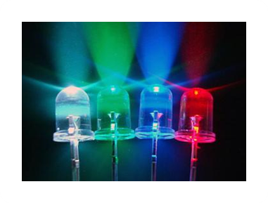
Photonics and LEDs
Lithography Simulation as a Gateway to Nanotechnology
Geoff Freymuth
Jefferson Middle School
2015-2016

Description:

To understand and apply the theory behind basic electronics. Students are challenged to engineer and manufacture a light-emitting diode (LED) simple circuit using basic photolithography simulations.
The processes for the manufacturing of LED’s has been widely accepted and commercialized with many everyday uses of LEDs. As LEDs become common place there is a need to further expand their use and also increase their efficiency. One of the basic processes involved in part of the making of an LED is photolithography. This process can be simulated on a larger scale to mimic a portion of the process in a middle school classroom.
This unit will also consist of a multimedia project where students’ present ideas to highlight the importance of light and optical technologies in our lives and for the development of society.
Essential question- What are the possible future uses of light emitting diodes? How can band gap energy engineering or “tuning” of the LED wavelength frequencies impact LED efficiencies and uses?
Students will design a simple series or parallel circuit using Circuit Construction Kit Virtual Lab, http://www.docircuits.com/, or similar. Students will then simulate the photolithography process. This can be accomplished with overhead transparencies, photosensitive craft paper, copper tape, inexpensive LED light source and AA batteries.

Learning objectives:
- Understand and apply concepts of electrical circuits, current electricity, battery, conductivity, switch, circuit symbols, LED light.
- Be able to understand and apply engineering design process
- Develop manufacturing skills: innovation, design, build, test
- Help students to understand that technology is closely linked to creativity, which has resulted in innovation.
- Understand the basic fabrication techniques of photolithography in the manufacturing of integrated circuits and LEDs.
- Understand the importance of light and optical technologies in our lives and for the development of society

Prerequisite knowledge/skills:
Basic concepts of electrons, atoms, current, measurement and units.
Prior knowledge needed- What is an LED, LED basic components, LED uses, basic circuits

Duration: 4-5 classes (50 minutes each)

Target grade level(s): 6-8

Target subject(s): Electronics, math, physics, advanced manufacturing

Alignment with Next Generation Science Standards:

MS-ETS1-1. Define the criteria and constraints of a design problem with sufficient precision to ensure a successful solution, taking into account relevant scientific principles and potential impacts on people and the natural environment that may limit possible solutions.

MS-ETS1-2. Evaluate competing design solutions using a systematic process to determine how well they meet the criteria and constraints of the problem.

Science is a Human Endeavor Advances in technology influence the progress of science and science has influenced advances in technology. (MS-PS4-3)

Structure and Function Structures can be designed to serve particular functions by taking into account properties of different materials, and how materials can be shaped and used. (MS-PS4-2)
Structures can be designed to serve particular functions. (MS-PS4-3)

Influence of Science, Engineering, and Technology on Society and the Natural World Technologies extend the measurement, exploration, modeling, and computational capacity of scientific investigations. (MS-PS4-3)

Background:
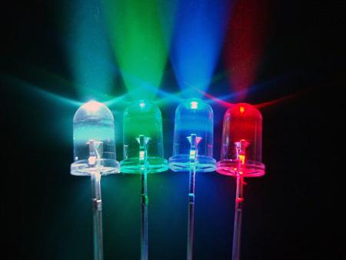
A Light Emitting Diode (LED) is a small manufactured device that will provide a single color of light. When you buy a LED you can select one that produces a green light, red light, yellow or blue light. LEDs are available across the visible, ultraviolet and infrared wavelengths, with very high brightness. LEDs have many advantages over incandescent light sources including lower energy consumption, longer lifetime and smaller size. However, LEDs are still relatively more expensive than fluorescent lamp sources of comparable output. LEDs applications are as diverse as aviation lighting, automotive headlamps, advertising and traffic signals, and camera flashes.
Photolithography is the major method of fabrication of integrated circuits (ICs) and LEDs. Computers, calculators, digital audio players, cell phones, televisions, flat-panel displays, smart appliances, and even cars contain ICs. It is important for students to learn about today’s technologies and how they are made. Gaining an understanding, familiarity and interest in such areas will help the next generation of scientists and engineers to continue the advancements of science for the benefit of society.

The vast majority of these billions of integrated circuit components that were produced over the last 50 years have been fabricated using a process known as photolithography. The ICs, LEDs and their components must be constructed layer-by-layer, with many components being built all at the same time in their proper spatial relationship to one another.

Photolithography uses patterns of light and shadows to ultimately produce two-dimensional patterns in the layers that comprise the LED. At the heart of the photolithographic process is a polymeric material called photoresist. A photoresist is typically comprised of a sensitizer, a resin, a solvent, and other additives. When light strikes a layer of photoresist, it causes chemical changes to take place within the polymer, which in turn changes the ability of the photoresist to dissolve in various solutions. This allows specific areas of the photoresist layer to be removed, exposing the LED surface below these areas for further chemical treatment.

The “light” most commonly used in photolithography is ultraviolet (UV) light. UV light has gained notoriety for causing sunburns and skin cancer; this is because it is shorter in wavelength, higher in energy, and more capable of breaking chemical bonds than visible light. The minimum size of the features produced by photolithography is limited by the wavelength of light used; therefore, researchers have sought to use shorter and shorter wavelengths of light in order to produce smaller features.

The solutions that selectively dissolve the photoresists are referred to as developers. Developers produce a copy of the mask pattern in the photoresist layer once the more soluble part is dissolved away. Once patterned, the exposed LED surfaces (the substrate) below the photoresist layer can be treated in one of two ways:
• Etching: A portion of the exposed LED surface is removed. The remaining photoresist acts as a protective layer.

• Deposition/lift-off: New material is added on top of both the exposed and the photoresist-covered LED. However, when the remaining photoresist is removed from the LED, the new material directly above it is also removed. The new material directly above the exposed LED surface adheres to the LED, adding to its structure.

The photolithographic cycle can then be repeated:
1. deposit photoresist on the substrate
2. use light to expose the photoresist
3. use developer to remove the more soluble portions of the photoresist
4. etch away or deposit upon the exposed areas of the substrate
5. wash away the remaining photoresist

These five photolithographic (PL) steps can be demonstrated using overhead transparencies, photosensitive craft paper, copper tape, inexpensive LED light source and AA batteries

Preparation time: 1 hour

Materials/supplies/equipment needed with example source listed/pricing
Copper Tape | $13.31 | Copper Conductive Adhesive Tape, 1/4" Width, 2.75 mil Thick, 36 yd Length  http://www.amazon.com/Copper-Conductive-Adhesive-Width-Length/dp/B009KB86BU  UPC 696738593107  EAN 0696738593107 | 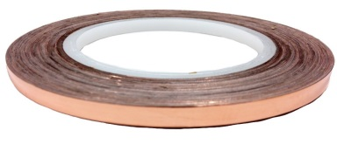
Overhead Transparencies | $ 13.99 per 50 sheets | Apollo Laser Jet Printer and Copier Transparency Film, 50 Sheets (CG7060)  http://www.amazon.com/Apollo-Printer-Copier-Transparency-Sheets/dp/B0040YC7FI/ref=sr_1_2?s=office-products&ie=UTF8&qid=1459784683&sr=1-2&keywords=overhead+transparency+sheets | 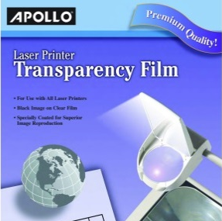
Photosensitive Craft Paper | $11.89 per 15 sheets | SunPrint Paper Kit  http://www.amazon.com/SunPrint-W330-Paper-Kit/dp/B001KOGY3M/ref=sr_1_3?s=toys-and-games&ie=UTF8&qid=1459785007&sr=1-3&keywords=photo+sensitive+paper | 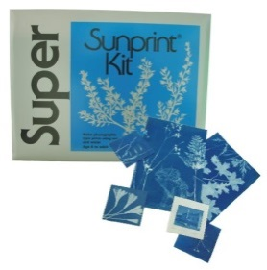
LEDs | $ 1.99 ea. | Radio Shack 5mm LED Lights  various colors.  https://www.radioshack.com/search?q=LED%20light%20%20tag:productType_leds | 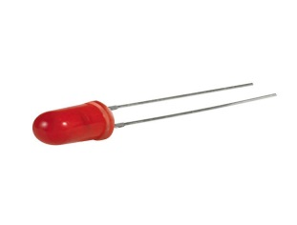
Circuit Construction design program (free online) | free | https://phet.colorado.edu/en/simulation/circuit-construction-kit-dc  or  http://www.docircuits.com/ | 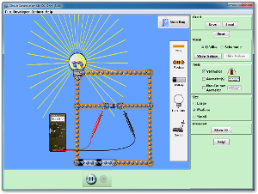
Optional- Circuit Scribe | $59.99 basic kit | http://www.electroninks.com/ | 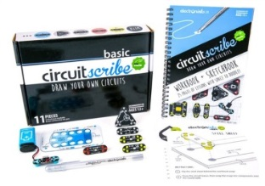
Optional- Arduino | $99.90 | https://www.arduino.cc/en/Main/ArduinoStarterKit | 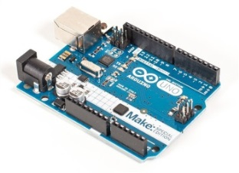

Procedure/activity:
Basic steps or process
Design Problem- Imagine that you are a technician or an engineer and your next assignment is to test different types of Light Emitting Diodes to determine the best LED to use for future greenhouse use or for use I future space explorations. Students will design/draw simple circuit with at least one LED, switch, and an addition item (buzzer, 2nd light, sensor etc.) using Circuit Construction Kit Virtual Lab, http://www.docircuits.com/, or similar.
- Student designs will then be printed on overhead transparency.
- Transparency will be used as mask with photo sensitive paper and sun light/or UV to imprint circuit onto photo paper.
- Circuit will then be etched
- Copper foil tape will be traced or put down on circuit with components attached. (as alternative circuit scribe ink can be used)
- Students add power supply and test circuit.
- Students trouble shoot problems/redesign
- Follow up- measure voltages across power source and light sources, compare series and parallel efficiencies/brightness

Project Videos

Motivational and background information about LEDs and photonics. To be used prior to starting the project and introducing the student research project.
https://www.powtoon.com/online-presentation/cGS7snIxFn1/photonics-led-info/

Instructional video for students and teachers with side by side comparisons of actual photolithography process with the class simulation.
https://www.powtoon.com/online-presentation/bESBAjzoivW/instructional-video/
Presentation talking points on the actual Lithography process.
https://www.powtoon.com/online-presentation/d9EW5ZJn2x6/photolithography-steps/

Slide 1: Introduction- compare lithography to photography

Slide 2: Lithography uses light or other forms of radiant energy to change the chemical properties of thin layers of films that have been coated on a substrate. The film provides a precisely patterned “stencil” that can be used in the process to mask out certain areas of the substrate from exposure to chemical or physical deposition or etching that occurs later in the process. Since the top-down process starts with a “chunk” of material and then adds or removes other materials from it to create the desired object, defining precisely where to do this is a critical component.

Slide 3: In the top-down model, we use these 4 processes to create features in certain areas of the substrate. The thin film patterns created in lithography can mask the substrate from being etched by strong chemicals or define areas where metal layers can be added for wiring. With doping, we change the physical properties of certain areas of the substrate. Lithography also masks off areas for this process.

Slide 4: The lithography process is repeated many times during fabrication of a device, since there are often several “layers” of materials added to a substrate. With this multilayer manufacturing method, if one layer doesn’t line up with the one below it or if the areas overlap each other, the final device will not work.

Slide 5: Photolithography is one of the lithographic methods most commonly used in the top-down process. A top down view of the photolithography process shows that the light is controlled by a masked off area and focused onto the area to be patterned through a lens. In subsequent slides, we’ll show how the photosensitive surface was placed there, and how the properties of the light and the patterns in the mask affect the finished product.

Slide 6: Photoresist is made up of chemical compounds whose properties are changed by exposure to radiant energy. Typically, the photoresist chemicals are in a liquid solution that is applied to a silicon wafer in a device called a spinner. The silicon wafer must be clean, flat, and dry in order for the spin process to create a flat, uniform coating of the resist. If the coating is not uniform, the pattern created will not be even (planar). Gaps or holes in the coating may allow chemicals and other physical processes to “seep through” areas where they should not be occurring and cause the device to be rejected. The “recipe” that defines the speed, temperature of the wafer, and timing for each part of the spinning process is unique to the photoresist being applied.

Slide 7: Photoresist coatings are baked onto the surface after coating to harden, drive off volatile compounds, and ensure that they will adhere to the surface during processing. Since the coatings must be even across the surface, it is necessary to remove the “edge bead” that occurs during the spinning process. When the bake and edge bead removal are completed, the wafer is ready for the next step. Photoresists differ in their chemical makeup based on the energy source that they respond to and the type of processing step that they must act as a mask for. In some of the newest processes for the top-down method known as stamp pad lithography, the resists are intentionally soft and respond to pressure from a patterned stencil that is applied into the wafer, accompanied by heat or light rather than just light alone, as is the case in photolithography.

Slide 8: Photomasks provide the definition of the light patterns that will strike the photoresist. A photomask can be compared to a photographic negative from which a picture is made. The photomask, just like the negative, has the image of the pattern to be “printed”. The accuracy of the shapes on the photomask defines the accuracy of the printing. Photomasks are generally manufactured from quartz plates that are especially flat and planar that have been coated with a chromium plating layer. The chromium plating blocks light from passing through. To create a photomask, electron beam patterning tools are often used, as the beam width is exceptionally small. This is a very time consuming process as a result, but the accuracy and precision of the mask is essential to the process. In some cases, the term reticle is used in place of mask.

Links to the research articles and other resources:

1) Presidential initiative of the Institute for Manufacturing Innovation on Integrated Photonics http://manufacturing.gov/ip-imi.html
2) 2014 Nobel Prize in Physics: "for the invention of efficient blue light-emitting diodes which has enabled bright and energy-saving white light sources". Http://www.nobelprize.org/nobel_prizes/physics/laureates/2014/
Basics of Light Emitting Diodes and Light Technologies:
3) DOE Solid State Lighting Facts: http://energy.gov/eere/ssl/ssl-basics
4) Official 2015 Year of Light Webpage: http://www.light2015.us/
READING: NEWS AND FUN ARTICLES:
1) Light Science for Kids http://www.interior-deluxe.com/light-science-for-kids.html
2) Warning labels on your light bulbs http://www.cnn.com/2015/06/09/health/light-bulbwarning/?iid=ob_homepage_deskrecommended_pool&iref=obnetwork
Optical Illusions Show How We See Beau Lotto's color games puzzle your vision, but they also spotlight what you can't normally see: how your brain works. This fun, first-hand look at your own versatile sense of sight reveals how evolution tints your perception of what's really out there. Watch Video
A Light Switch for Neurons Ed Boyden shows how, by inserting genes for light-sensitive proteins into brain cells, he can selectively activate or de-activate specific neurons with fiber-optic implants. With this unprecedented level of control, he's managed to cure mice of analogs of PTSD and certain forms of blindness. Watch Video
Playing with Space and Light In the spectacular large-scale projects he's famous for (such as "Waterfalls" in New York harbor), Olafur Eliasson creates art from a palette of space, distance, color and light. This idea-packed talk begins with an experiment in the nature of perception. Watch Video
Why Light Needs Darkness Lighting architect Rogier van der Heide offers a beautiful new way to look at the world — by paying attention to light (and to darkness). Examples from classic buildings illustrate a deeply thought-out vision of the play of light around us. Watch Video
Magic Bullets Dr. Rox Anderson talks about "Magic Bullets,” specialized light-energy treatments that can remedy skin abnormalities and help kids lead normal lives. Watch Video
Science Unplugged - What is Light? World Science University provides hundreds of short video answers to a wide range of scientific questions, like this one on “What is Light.” Watch Video
Folding Objects with Light (Courtesy of Inside Science) Chemical engineers developed a way to transform two-dimensional patterns into three- dimensional objects using only light. Watch Video
Invisible Touch Screen (Courtesy of Inside Science) Computer scientists and engineers at Texas A&M University use crisscrossing beams of invisible light to create a virtual air touchpad computer interface. Watch Video
I would like to thank my research mentor Dr. Can Bayram, ICOR lab members, Wui Chung Yap, Connor Bailey, and Josh Perozek, RET project manager Carrie Kouadio, technical staff at MNTL, Dr. Nancy Johnson, the Micro and Nanotechnology Lab, and my fellow (2015) RET cohort participants.
Financial support was provided by the National Science Foundation under grant #NSF EEC 14-07194 RET, as part of the nano@illinois project, through the University of Illinois Center for Nanoscale Science and Technology and the Micro and Nanotechnology Lab at the University of Illinois at Urbana-Champaign.

This work, which includes teacher and student resources, is licensed under a Creative Commons Attribution-Noncommercial-Share Alike 3.0 Unported License. To view a copy of this license, visit: http://creativecommons.org/licenses/by-nc-sa/3.0/. To attribute this work, please use [“J. Doe. Title (Date).”]
The nano@illinois Research Experience for Teachers (RET) at the University of Illinois at Urbana-Champaign (from 2014-2017) exposes a diverse set of in-service and pre-service science, technology, engineering, and mathematics (STEM) teachers and community college faculty from across the nation to cutting-edge research in nanotechnology. The RET focuses on recruiting underrepresented minority populations (focused on ethnicity, geography, disability, and veteran status) including women and will target teachers from high-need areas, including inner city, rural, low-income, and those with significant URM students. Participants conduct research over 6 weeks in world-class labs with 4 follow-up sessions during the school year.
Teacher professional development opportunities includes teacher-focused lectures, mentoring, networking, poster sessions, ethics seminars, hands-on modules, STEM education issues, career choices, and resources for implementing a nano lab and curriculum. Teachers will develop modules to be disseminated widely and present their results. High-quality follow-up sessions and evaluation will be infused.

The nano@illinois Research Experiences for Teachers (RET) is managed by the University of Illinois Center for Nanoscale Science Technology.

Center for Nanoscale Science and Technology
208 N. Wright, MC-249
Urbana, Illinois 61801
217-244-1353
nanotechnology@illinois.edu
www.nano.illinois.edu

